**4.2.2 Subsystem decomposition**

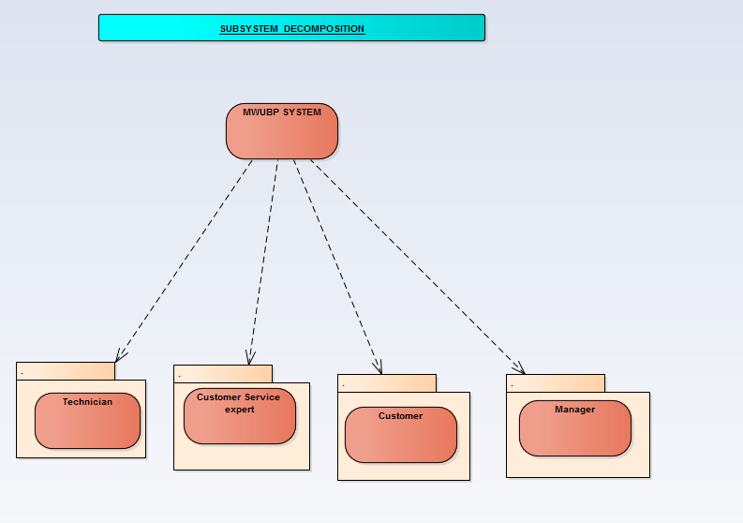

**Subsystem decomposition description**

|  |  |  |
| --- | --- | --- |
| **Subsystem** | **Purpose** | **Class** |
| **Manager** | * Manage employee * Login * View report * Logout | * Manager * Expert * Technician * Report |
| **Customer** | * Pay bill * View history * Request maintenance * Login * logout | * Customer * Bill * Meter * History * Request |
| **Technician** | * Read meter * Log in * Register meter * Approve maintenance * Log out | * Technician * Meter * Maintenance |
| **Expert** | * Manage customer * Assign technician * View request * login * Bill generate * Make report * logout | * Expert * Request * Report * Bill * Customer |